September Problems
Number Theory
Start out simple...
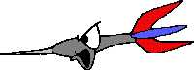
1. List 10 possible combinations you could get with 4 darts. The numbers on the targets are 7-5-3-1. Try to establish some logical method of doing this.

2. Compare different pay scales. Decide if it is better to receive $300 a week or to be paid hourly at a rate of $7.50 per hour. What factors could affect your decision?

Now try to work this out...
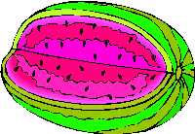
3. Three watermelons and two cantaloupes weigh 32 pounds. Four watermelons and three cantaloupes weigh 44 pounds. All watermelons weigh the same and all cantaloupes weigh the same. What is the weight of two watermelons and one cantaloupe?

4. Sylvester measured his pulse and found that his heart beat at a rate of 80 beats a minute at rest. At this rate, how many days will it take his heart to beat 1,000,000 times? Show your work and be sure you explain each step.

This will really challenge you...
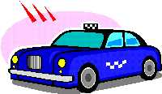
5. Conrad's Taxi Service charges $1.50 for the first mile and $.90 for each additional mile. How far could Mr. Kulp go for $20 if he gives the driver a $2 tip?

Measurement
Start out simple...
Rabbit's Run (taken from MATH FORUM)
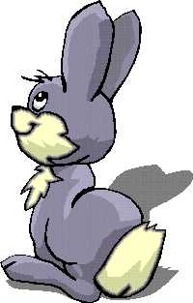
6. Regina has received a pet rabbit from her neighbor Rodney who is about to move to an apartment that does not allow pets. Her father is going to help her build a run for the rabbit in their back yard, but he wants Regina to design it.
Regina sits down to think about the possibilities. Her father says that the run must be rectangular with whole number dimensions. If they want to enclose 48 square feet, how many options do they have?

Now try to work this out...
Area And Perimeter
7. If you fold a square paper vertically, the new rectangle has a perimeter of 39 inches. What is the area of the original square?
What is the perimeter of the original square?
What is the area of the resulting rectangle?
Make a ratio of areas and perimeters. What do you notice?

This will really challenge you...
Better Buy
8. Mr. and Mrs. Simpleton are shopping for carpet for their living room and dining room. Their living room is 21 feet by 15 feet and their dining room is 12 feet by 9 feet. They have looked at two different priced carpets. One for $14.95 a square yard installed and another for $19.99 a square yard installed. How much would they save by choosing the cheaper carpet? What are some other things besides money that they should consider before making their choice? After you find out how much carpet they need, figure out the savings in one calculation. Explain.

Geometry
Start out simple...
Where Am I?
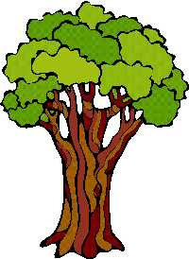
9. Tom Terrific has a garden in the shape of a rectangle. He wanted to plant a tree in a specific spot. He wanted it to be in the exact center of the garden. What would be a way that he could find the center without using any measurement?

Now try to work this out...
Reflections
10. Find 2 polygons other than a square and rectangle whose reflections are identical to the original. Draw them.
Show how the reflection of a triangle can be the same as the original.

This will really challenge you...
Symmetry
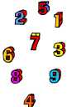
11. What is the largest three digit number that has both vertical and horizontal symmetry? Think of a three letter word with horizontal symmetry.

Patterns, Algebra, And Functions
Start out simple...
Going Camping
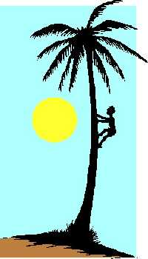
12. Groups of campers were going to an island. On the first day 10 went over and 2 came back. On the second day, 12 went over and 3 came back. If this pattern continues, how many would be on the island at the end of a week? How many would be left?

Now try to work this out...
A Batty Diet
13. A bat ate 1050 dragon flies on four consecutive nights. Each night she ate 25 more than on the night before. How many did she eat each night? Solve this algebraically.

This will really challenge you...
Windemere Castle (From The Problem Solver)
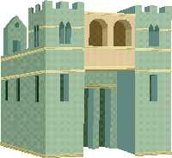
14. Evelyn is reading about Windemere Castle in Scotland. Many years ago, when prisoners were held in various cells in the dungeon area, they began to dig passages connecting each cell to each of the other cells in the dungeon. If there were 20 cells in all, what is the fewest number of passages that had to be tunneled out over the years?

Data, Statistics, And Probability
Start out simple...
Bouncing Babies (Taken from MATH FORUM)
15. At a baby shower, we started discussing baby statistics. One of the women told us she had heard a report that for every 100 babies born, there were 6 more boys than girls. If we were to randomly pick a child from a representative group, what is the probability of picking a girl?

Now try to work this out...
Trees
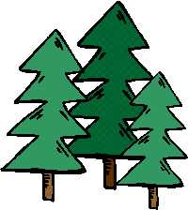
16. A team of scientists found that there were 4 oak trees for every 10 pine trees. How many oak trees were there if they counted 36 more pine than oak?

This will really challenge you...
Cookies!
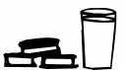
17. Four friends buy 36 cookies for $12. Each person contributes the following amount of money:
Tom--$2
Jake--$3
Ted--$4
Sam--$3
Each person gets the number of cookies proportional to the money paid. Draw a circle graph to represent the amount of cookies each got.
Draw another circle graph to show how many each would have if Ted gives half of his cookies to Tom.

Grab Bag
Up You Go!
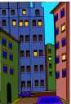
18. In the old days there were elevator operators to transport passengers. Don Downs always started his day in the basement. He went up 20 floors to take his boss some coffee. Then he went down 8 floors to take a Danish to his friend. He went up 7 floors to check things out. This was the halfway point in the building. How many floors are in this building? Draw a diagram to show how you would figure this out.

October Problems
Number Theory
Start out simple...
What's the Deal?
1. Mortimer wants some doughnuts. He is very cheap and likes to save even the smallest amount of money. He found a coupon in the paper for Dunkin' Donuts.The coupon was for $1 off a dozen. This week they are on sale for $3.99 a dozen without the coupon and $.35 a piece if you use the coupon. What do you think Mortimer will do and why?

Spinning
2. Tara and Sara are going to play a spinner game. These are the rules:
- When it is a player's turn, you spin both spinners.
- Add the 2 numbers that the spinner points to.
- If the sum is odd, Tara wins even if it is not her turn.
- If the sum is even, Sara wins even if it is not her turn.
Both girls think that they have a better chance of winning. Is either right? Justify your answer.

Now try to work this out...
Going Shopping
3. Mabel and her mom are going shopping on Saturday. They bought at least one item from each of the 3 departments that they visited. Mabel gave the clerk $120 and she got back $11.76 change. What items did they buy? Think about how much they spent. NO TAX TODAY!
HOUSEWARES
Dishtowels: $11.38
Curtain Rods: $12.98
Bath Mats: $29.58
CLOTHING
Shirt: $30.98
Dress: $49.90
Slacks: $39.90
TOOLS
Hammer: $17.90
Saw: $23.90
Drill: $25.78

What Time is It?
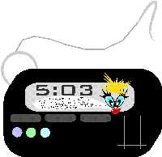
4. How many times in a 12 hour period does the sum of the digits on a digital clock equal 6? Try to think of a way to solve this without going through every single time. Describe what you did.

This will really challenge you...
Boy Scout Hike
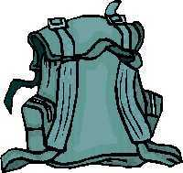
5. Points A and C on a map are 12 km apart if you follow a certain path. A troop of Boy Scouts leaves Point A at 11:00 a.m. They travel 3 km/hr because they have heavy packs until they reach Point B at 12:45. If they want to reach Point C by 2:00, how fast will they have to go?

Measurement
Start out simple...
Baseball Trivia
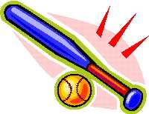
6. The greatest distance that a baseball has been thrown is 445 feet, 10 inches. Is this greater or less than the length of a football field from goal line to goal line? By how much? Tell how you made your decision.

Now try to work this out...
Picture It
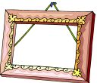
7. A picture that measures 12 cm by 18 cm is enlarged to 4 times its area. What are the new dimensions?

This will really challenge you...
The Nutty Squirrel - From Math Forum
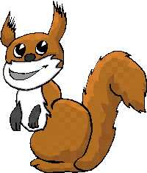
8. While going for my daily run, I passed a squirrel carrying a nut in her mouth. When she saw me, she ran towards a safe place and, coming to a stone wall, easily jumped up on it and disappeared. I began to wonder how high I could jump if I were a squirrel.
If an average squirrel's back leg height from ground to hip is 3 1/2 inches, and that squirrel can jump a 2 foot high wall, what height wall could I jump if I were a giant squirrel? My leg height from ground to hip is 36 inches. Give your answer in feet and inches to the nearest inch.

Geometry
Start out simple...
9. Which of these choices contains the dimensions of a rectangle with the same perimeter as a rectangle whose dimensions are 5 m by 3 m.?
- 10 m by 8 m
- 7 m by 1 m
- 6 m by 4 m
- 8 m by 2 m
Show your work.

Now try to work this out...
A Model House
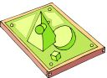
10. Choose 3 geometric solids to build a model house. What solids did you choose? How many vertices are there? From an aerial view of your structure, how many vertices can you see? Draw a picture of the aerial view.

This will really challenge you...
11. What do you need to know to solve this? You have kite ABCD. Angle B is at the top of the kite and measures 80 degrees. Angles A and C are on the sides and Angle D is at the bottom of the kite. What is the largest size that Angle A or C could be?

Patterns, Algebra, And Functions
Start out simple...
Yum
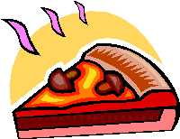
12. Determine the number of pizza combinations you could get with 4 different toppings. Each pizza must have at least 2 toppings. Make a chart to display your results.

Now try to work this out...
Ice Cream Cones
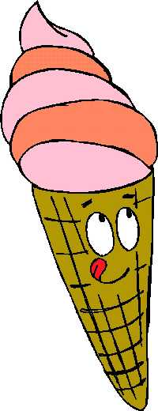
13. An ice cream stand has 9 different flavors. A group of children come to the stand and each buys a double scoop cone with 2 flavors. If none of the children chooses the same combination of flavors and every combination is chosen, how many children are there? Show how you got your answer.

This will really challenge you...
Planet Krayon - (From The Problem Solver 6)
14. Zemo, Orb, Yuko, and Sam are friends who live on neighboring space stations of the planet Krayon. They commute to school every day by space shuttle. Orb's space station is one half as far from Krayon as Zemo's space station. Yuko travels as far as the total distance traveled by Zemo and Orb. Sam travels 3 times the distance that Zemo travels. How many space miles does each friend travel to school if the friends together travel 888 space miles?
Write an algebraic equation.

Data, Statistics, And Probability
Start out simple...
Coin Toss
15. List all the possible outcomes when four coins are tossed. Determine the theoretical probability of having exactly two heads and two tails.

Now try to work this out...
Graph It!!!
16. Use the following information to make a line graph, bar graph, and circle graph. Describe how you did each one in paragraph form. Choose a title, labels, and scale.
Doritos - 20
Popcorn - 15
Candy - 12
Chips - 10
Pretzels - 3

This will really challenge you...
How Old Am I?
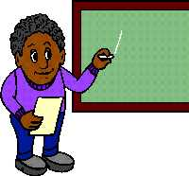
17. The average age of a group of teachers and students is 20. The average age of the teachers is 35. The average age of the students is 15. What is the ratio of teachers to students? Express your answer as a fraction in simplest form.

Grab Bag
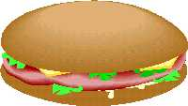
18. Dominic arrived at work and went behind the counter at the north end. As he faced out over the counter, north was to his right, south to his left. While he was standing at the north end, a customer ordered a sandwich. Dominic went through these steps:
- 3 feet to his left to pick up the bread
- 2 feet to his right to put bread on the plate
- 4 feet to his left to get mayo and pickles
- 2 feet to his left to pick up knife and spoon
- Returned to where the bread was on the plate
- Turned around and got the salami out of the refrigerator
- Put the sandwich together
- 3 feet to the left to serve the customer
- 4 feet to the left to get a soda
- Back to the customer to give him the soda
- To the south end of the counter to pick up the customer's money
Draw a diagram of the counter and its arrangement. Make suggestions for a more efficient arrangement.
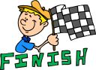
November Problems
|
Number Theory
Start out simple...
Dining Decisions
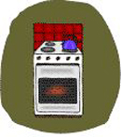
1. Mrs. Phillpott is a cook for the Thornberry family. She usually makes a 5 pound roast for dinner on Thursdays. She knows that it takes 2 1/2 hours to cook this roast. Her boss is having a dinner party and she needs to make more food. She decides that she needs 15 pounds of meat. The problem is that she only has one oven and it will not hold a roast bigger than 10 pounds. How could she solve this problem? Answer in paragraph form.

Change
2. Sadie went to the store with a $10 bill. She spent $4.76. Give 6 possible ways she could get her change. She cannot use the same number of coins twice. (You cannot say 5 one dollar bills, 2 dimes, 4 pennies, and then a $5 bill 2 dimes and 4 pennies.) She must use each type of United States coin at least once.

Now try to work this out...
Bagging Potatoes
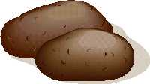
3. A farmer grows 196 pounds of potatoes. He sells them to a grocer who divides them into 5 pound and 2 pound bags. If the grocer uses the same number of 5 pound and 2 pound bags, how many bags of each did he use?

Mug-Making Mary (from THE PROBLEM SOLVER 6)
4. Mary McDonald makes mugs in Miami. She makes two sizes of mugs: a small mug that she sells for $2.50 and a large mug that she sells for $5.75. Yesterday Mary made $56. Before she opened her shop in the morning, she had 200 mugs in her inventory. At the end of the day she has 188. How many mugs of each price did she sell?

This will really challenge you...
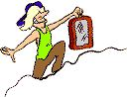
5. Find out how much per ounce each of these sells for. Then arrange them from the most expensive to the least expensive.
Gas $1.65 per gallon Snapple $1.29 for 16 oz.
Gatorade $1.59 for 20 oz. Lipton Iced Tea $1.19 for 16 oz.
Ocean Spray $2.54 for 30 oz. Evian Water $1.49 for 9 oz.
NyQuil $8.35 for 6 oz. Pepto Bismol $3.85 for 4 oz.
Whiteout $1.39 for .8 oz. Scope $$.99 for 1.5 oz.

Measurement
Start out simple...
Space Measurement
6. An object weighing 5 pounds on Earth will weigh 2 pounds on Mercury. The Statue of Liberty weighs 225 tons. What would it weigh on Mercury?

Now try to work this out...
Garden
7. Farmer Brown is making a garden 14 1/2 feet long and 8 3/4 feet wide. He puts up a fence 23 1/2 feet long and 17 3/4 feet wide. What is the distance from the fence to the edge of the garden?

This will really challenge you...
TV Time
8. Gretchen is going to "Best Buy" to get a new TV. She already has a cabinet and she wants to be sure that the new TV will fit. Her cabinet is 24 inches wide by 24 inches high by 12 inches deep. She wants to have 1 inches on each side, 1 inch on top and 1 inch behind so the TV will slide in easily. Which of these would be her best choice?
- Volume of 5280 cu. in. w = 22", h = 20"
- Volume of 5290 cu. in. d = 10", base and height the same
- Volume of 5566 cu. in. w = 22", d = 11"

Geometry
Start out simple...
Meow!
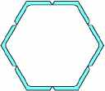
9. Draw a cat, but you may only use regular polygons and you must use at least 6 different ones.

Now try to work this out...
Toothpick Fun
10. Carl is given 24 toothpicks and told to construct a geometric solid. He must use all of the toothpicks. Which solid could he make? Draw a picture to support your answer. How many balls of clay would he need to hold his structure together?

This will really challenge you...
Painting Problem
11. Brett has an assignment to paint all of the geometric solids for a museum display. His directions are to use the least amount of colors on each solid, but no sides that touch should be painted the same color. Tell how many colors will be needed for each solid:cube, triangular prism, hexagonal prism, octagonal pyramid, pentagonal pyramid. Is it true that the greater the number of sides, the more colors that are needed? Explain your answer in a few sentences and draw a picture.

Patterns, Algebra, And Functions
Start out simple...
Round Robin
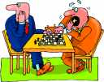
12. Six teams are involved in a round robin tournament. In such a tournament, each team plays every other team once and only once. It does not matter who wins the games. Therefore, how many games in all are played? You may want to call your teams A,B,C OR 1,2,3.

Now try to work this out...
Dots
13. Oblong numbers can be represented by rectangular arrays in which the number of dots in each row is one more than the number of dots in each column. The first 3 oblong numbers—2, 6, and 12—are represented below. Show the next 5 oblong numbers. How many dots are needed to represent the tenth oblong number?
** *** ****
*** ****
****

This will really challenge you...
Lucky Leaf Lettuce
14. Monday, the Produce manager, Arthur Applegate, stacked the display case with 80 heads of lettuce. By the end of the day, some of the lettuce had been sold. On Tuesday, the manager surveyed the display case and counted the number of heads that were left. He decided to add an equal number of heads. (He doubled the leftovers.) By the end of the day, he had sold the same number of heads as Monday.
On Wednesday, the manager decided to triple the number of heads that he had left. He sold the same number that day, too. At the end of this day there were no heads of lettuce left. How many were sold each day?

Data, Statistics, And Probability
Start out simple...
Car Colors
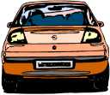
15. Raheem, Cary, and Jamar are having a discussion about which color car is the most popular. Raheem says white, Cary says black, and Jamar says silver. They stood at the intersection of Ridge Avenue and Domino Lane for an hour and kept a count. The results were: black=40; silver=60; white=80. Show 2 different ways that they could display their results.

Now try to work this out...
Brrrrrr!!!!!
16. Here are the average temperatures in Hawaii for 7 weeks in 1999 and the same 7 weeks in 2000. Determine which type of graph would be the most appropriate and make it. Don't forget labels, title, and the correct scale. Justify why you chose that type of graph.
1999 87 92 98 99 98 101 90
2000 91 92 99 102 100 88 89

This will really challenge you...
Randomly Speaking
17. There are an equal number of pennies, nickels, dimes, and quarters in a bag. What is the probability that the combined value of the four coins randomly selected with replacement will be $.41? Express your answer as a fraction in simplest form.

December Problems
Number Theory
Start out simple...
Family Fun - From Problem Solving Connections
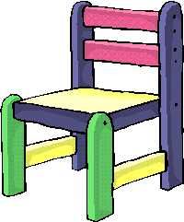
1. Four families each brought the same number of chairs to a block party. Three more chairs are needed to seat all 27 of the participants. How many chairs did each family bring?

Consecutive Numbers
2. An example of consecutive odd numbers is 23, 25, 27, and 29. Find four consecutive odd numbers with a sum of 160. Show your work.

Now try to work this out...
Opening Day
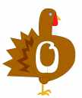
3. It is the grand opening of a local supermarket. Every 5th customer will receive a coupon for a free turkey and every 7th customer will receive a coupon for a free half gallon of ice cream. If 400 customers come in on opening day, how many will get a free turkey and a free half gallon of ice cream?

Kennel Klub
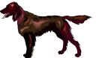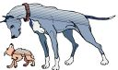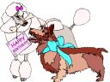
4. Four dozen dogs live in 6 different colored kennels. The smallest kennel has 6 dogs and the orange kennel is the largest with 10 canines. The yellow kennel and the green kennel are the only ones with the same number of dogs. The 13 youngest pups are in the red and blue kennels with the least number of dogs. The purple kennel has 2 more dogs than the blue kennel. How many dogs are in each kennel? Make a chart.

This will really challenge you...
Car Rental
5. Sam needs to rent a car for his upcoming trip. CheapWheels charges $20.25 per day plus $.14 a mile. Easy Rider charges $18.25 a day plus $.22 a mile. San plans to do a lot of driving on his 3-day trip. Which company should Sam go with? Explain your choice.
Does the difference in cost go up or down as mileage increases? Support your answer.

Measurement
Start out simple...
Flooring
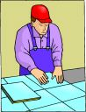
6. Mr. and Mrs. Corkwood were going to tile their den floor. They had tiled the kitchen floor earlier in the year with ceramic tile. The kitchen was 14ft by 10 feet. The den is 20 ft. by 14 ft. The kitchen tile job cost the Corkwoods $1400 including labor. How will this help them determine the price of the den floor?

Now try to work this out...
Squares
7. Look at this picture of squares. The area of square F is 16 square units. The area of square B is 25 square units. The area of square H is 25 square units. Find the area for square D and square E. Explain how you got your answer.
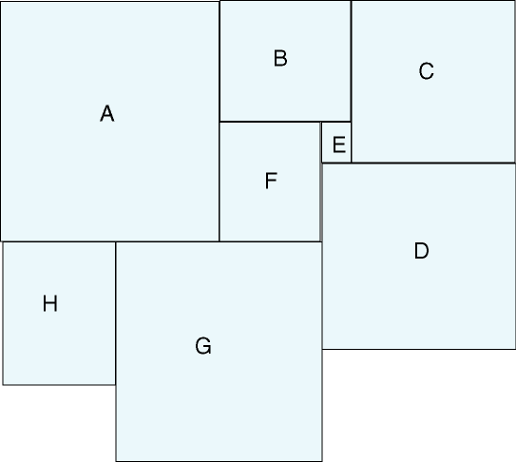

This will really challenge you...
Try It
8. A rectangular sheet of wood has 4 small squares removed. It is then cut to make a box that is 5 centimeters by 4 centimeters with a volume of 60 cubic inches. (Four pieces of wood size A-4 are removed.) Find the area of the original sheet of wood.
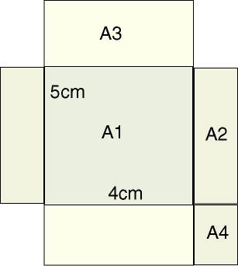

Geometry
Start out simple...
The Shape of Things
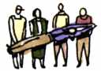
9. Look around your classroom and find as many different shapes as you can. Make a tally to help you determine which shapes are used most often. Why do you think this is so?

Now try to work this out...
Map It
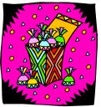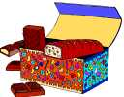
10. Willy Wonka went to Kandy Korners to see his friend. His friend told him how the town was set up and where to find the candy factory.
- Sweet Street, Rocky Road, and Almond Avenue are all parallel.
- Lollipop Lane is perpendicular to Rocky Road and ends at Sweet Street.
- Chocolate Boulevard is diagonal to Almond Avenue.
- The candy factory is bordered by Sweet Street, Lollipop Lane, Sour Patch Place, and Chocolate Boulevard.
Draw a map and put in the candy factory.

This will really challenge you...
11. Look at this shape. How would you go about finding the total area of this shape? Show how you would do this and then find the total area.
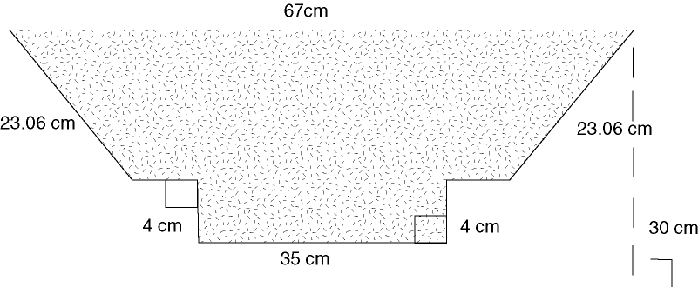

Patterns, Algebra, And Functions
Start out simple...
Rafting - From Problem Solving Connections
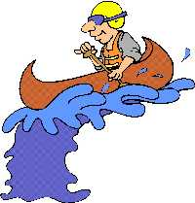
12. You are pulling a raft up a river. You can make 15 miles a day. At night, while you are asleep, however, the current pushes the raft 3 miles back downstream. If you set out on Tuesday to get to a town 85 miles upstream, on which day will you arrive?

Now try to work this out...
Stepping Up
13. Study this picture. How many blocks would you need for a 20-step staircase? Set up an algebraic equation to solve.
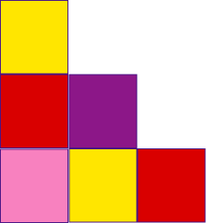

This will really challenge you...
Wacky Walter
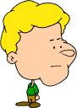
14. Walter and his parents are a little unusual. If he does an acceptable job of doing his chores, he gets paid $3.33 for that day. If he does an outstanding job, he gets $3 more. During one 10 day period, Walter received $42.30 for his work. How many days did Walter earn the extra money?

Data, Statistics, And Probability
Start out simple...
Happy Halloween
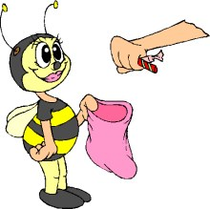
15. Pete went out for Halloween. He got tons of candy. He put all of his candy in a shopping bag. He got 80 different things. 30 were chocolate, 20 were gum, 25 were plain, and 5 were cookies. Make a circle graph to display his loot.

Now try to work this out...
Mean or Median
16. Sam made the following scores on unit tests for the term:
92, 98, 15, 92, 87, 92
Sam's teacher said that his grade would be based on the mean of his grades. Sam argued that his grade should be based on the median score of his grades. Find the mean and the median of Sam's grades. Which do you think best reflects Sam's work for the term? Explain your answer.

This will really challenge you...
Perfection
17. From 11 positive integer scores on a 10-point quiz, the mean is 8, the median is 8, and the mode is 7. Find the maximum number of perfect scores possible on this test.

Grab Bag
Be Careful
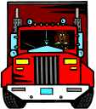
Tony's father is a driver for Brank's Armoured Truck Company. They take money from businesses to the bank. His last stop is at the largest hotel in the city where he collects a large sum of money. A map of part of the city showing the location of the hotel and the bank looks like this:
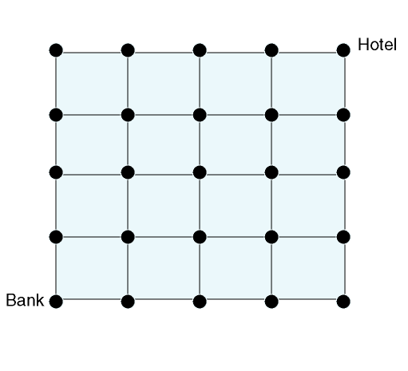
If Tony's father must take a different route every day to prevent a robbery attempt, how many different paths down and to the left can he take from the hotel to the bank?
January Problems
Number Theory
Start out simple...
French Fry Fun
1. There are about 20 potatoes in a 5 pound bag. A restaurant uses about 2 potatoes per order of French Fries. They charge $.95 for an order of Fries. How much money does the restaurant take in on a day that they use 400 pounds of potatoes?

Odd
2. The object of this activity is to find the sum of the first 25 odd counting numbers. One way is to add 1 + 3 + 5...continuing until you have added the first 25 odd numbers. However, this is too much work for the problem. Look for patterns and combinations to find a much easier way to solve this. Apply what you have learned from this problem and find the sum of the first 25 even counting numbers.

Now try to work this out...
Pump, Pump, Pump...
3. Your heart pumps about 5 quarts of blood through its chambers every 60 seconds. A swimming pool (20 ft. x 60 ft.) will hold about 65,000 gallons of water. This represents the amount of blood pumped by your heart in approximately how many weeks?

Going Shopping
4. The Carters are buying a new CD player. Three stores have the model they want on sale this week. Here are the ads:
Radio Shop: Regular Price=$200, Discount=20% off
Discount City: Regular Price=$180, Discount=30% off
Ralph's: Regular Price=$210, Discount=10% off and Extra 20% off
Which store will give the Carters the best buy and what will the price be? Show all of the steps and label your answer.

This will really challenge you...
Gas It Up
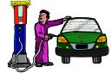
5. A car dealer claims that by buying a new car, Mike will pay 1/5 less for gas than he pays for the car he currently owns. If the car Mike currently drives costs 1/6 less to gas up than Dave's car, and Dave pays $700 per year, what will it cost Mike to put gas in a new car for 1 year? Assume all cars will be traveling the same distance.

Measurement
Start out simple...
To Scale
6. Use 1/4 inch graph paper and make a scale drawing of your room. Use the scale 1/4" = 1 '.

Now try to work this out...
Farmer Felix's Field
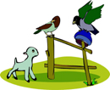
7. Farmer Felix needs to put up a fence around his field. The dimensions of the field are given in the diagram. But, he has a problem. He needs to be able to drive his tractor and needs 10 feet between the field and the fence. How many feet of fencing should he buy?
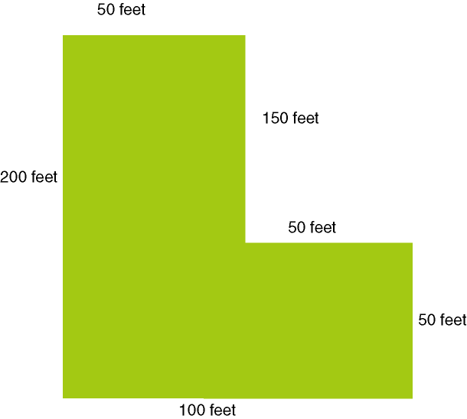

This will really challenge you...
The Great Flood Of 2000 - From MATH FORUM
8. On one Sunday in June of 2000, there was a great storm. Mr. Lui's basement got flooded! Mr. Lui wondered just how much water had to be cleaned up with his shop vac that held 12 gallons of water.
He knew that there were 7.48 gallons of water in one cubic foot of water and that he had 2 inches of water in the backwards `L' shaped section of his basement. (See diagram below.) How many gallons of water were in his basement and how many times did he have to empty his shop vac?
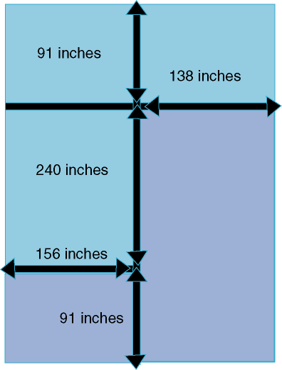

Geometry
Start out simple...
Spelling
9. Write the letters M, T, and H on figures 2 and 3 so that when the figure is folded into a box, it will spell MATH around the sides of the box. Figure 1 shows the correct placement of the letters. How did you decide on the letter placement?
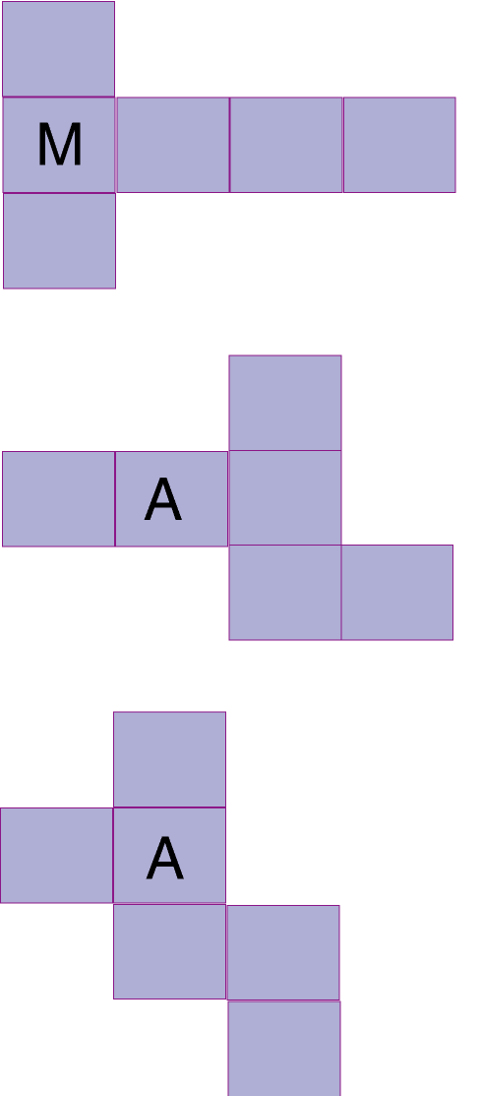

Now try to work this out...
Rotation
10. Find 3 upper case letters that look the same when rotated 180 degrees. Then, what letter's 90, 180, and 270 degree rotations has this outline? This is also the inside lines formed by the rotation of what letter?

Patterns, Algebra, And Functions
Start out simple...
Cookies
12. A boy ate 100 cookies in five days. Each day he ate 6 more than the day before. How many cookies did he eat on the first day?

Now try to work this out...
Walking To School
13. This line represents the line on a graph that shows how long it took Khalil to walk to school. The horizontal axis shows the time and the vertical axis shows blocks covered. Explain what you think happened on Khalil's way to school?
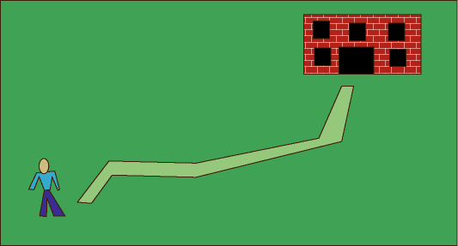

This will really challenge you...
Surprise, Surprise
14. Extravagant Ellie and Thrifty Tanya each have bank accounts. Ellie has $500 and Tanya has $200. Ellie withdraws $15 each weekend while Tanya deposits $12. At the end of 13 weeks, what is the difference in their bank accounts? Solve this algebraically. Can you find a week when there is only a $3 difference? Hint: It is before the 13th week.

Data, Statistics, And Probability
Start out simple...
What's In A Name?
A E I O U
15. Choose 10 students from your class. Tally the number of vowels in each person's name. Use this to predict the results for the rest of the class.

Now try to work this out...
PE Problems
16. Mr. Bulge has to give his class a sit-up test. There are 33 students in his class and he needs to display the data in such a way that he can easily examine the results. Think of 3 different ways that he could do this and justify your opinion.

This will really challenge you...
Things Change
17. Make a double bar graph to show the changes in sales for albums (1975) and CD's (1995). What conclusions can you draw?
YEAR: 1975
ALBUMS: 257,000,000
CDs: 0
YEAR: 1980
ALBUMS: 322,800,000
CDs: 0
YEAR: 1985
ALBUMS: 167,000,000
CDs: 22,600,000
YEAR: 1990
ALBUMS: 11,700,000
CDs: 286,500,000
YEAR: 1995
ALBUMS: 4,600,000
CDs: 613,000,000
February Problems
Number Theory
Start out simple...
Volunteering
1. Jack, Art, Fran, and Megan work as volunteers at the local kennel. Jack gives the dogs baths every 4 days; Art cleans out cages every 6 days; Fran feeds the animals in Section B every 2 days; and Megan helps the receptionist every 3 days. How many times in 12 weeks will all 4 helpers be at the clinic on the same day?

TV Watching Time
2. For a school Project, Ron recorded how much TV he watched in one weekend and what kinds of programs he watched. This chart shows the time he watched TV:
SATURDAY: 9:30-10:30AM; 1:00-3:30PM; 8:00-10:00 PM
SUNDAY: 1:00-2:30PM; 8:00-10:00PM
Ron watched sports programs for one half of the time. He watched movies for one third of the time. He watched cartoons with his sister Ronnette the rest of the time. How many minutes did Ron watch cartoons? Make sure you explain all of the steps and label your answers.

Now try to work this out...
Tadpoles and Minnows
3. In one pond in the forest, scientists found that a sample of pond water contained 45 minnows for every 27 tadpoles. How many tadpoles would they expect to find in a sample that contained 315 minnows? Make a chart to show the relationship between tadpoles and minnows.

Fabulous Fudge
4. The Fabulous Fudge Emporium serves fudge made from an old secret recipe. Marvin works at the shop after school. He does not know what all of the ingredients are, but he knows that in 3 days they use 15 pounds of dark chocolate, 30 pounds of sugar, and 21 pounds of butter. When Marvin orders chocolate, sugar, and butter for 3 weeks, how many pounds of each ingredient does he order?

This will really challenge you...
Gassing Up
5. Derrick started his car, an automatic, and drove 8 miles. He spent 2 minutes at a stop light. Dawn drove her car, manual shift, and went 9 miles with no stops. Who used more gas? Use this chart and justify your answer.
TABLE OF GAS MILEAGE
 | Automatic | Manual
Idling | .16 Gal/Min. | .16 Gal/Min.
Starting | .05 Gal. | .05 Gal.
Moving | 1 Gal/22 Miles | 1 Gal/20 Miles

Measurement
Start out simple...
Plastic
6. Each American throws away about 60 pounds of plastic packaging each year. At this rate, about how many years will it take one person to throw away a ton of plastic?

Now try to work this out...
Movin' On
7. Mr. and Mrs. Quigley just moved into a new home with a lot of land. They need to plant grass seed. The problem is that they are not sure how to figure the new amount that they need. At their old house, they knew that the lawn was 10 ft. by 20 ft. and needed 5 pounds of seed. Their new lawn is 100 ft. by 50 ft. How will knowing the amount of seed needed from their old house help them with buying seed for the new lawn?

This will really challenge you...
Fencing
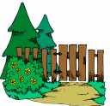
8. The Andersons are buying a new home. They need to fence the yard because they have a dog. The yard is 72 ft. by 120 ft. Each fencing section is 8 ft. How many sections will they need? How many posts will they need? (a post is needed at the end of each section). What else will they need?

Geometry
Start out simple...
Diagonally Speaking
9. What is the maximum number of diagonals in an octagon? Solve this without drawing the shape. (Start with smaller polygons and search for a pattern). Once you have determined the pattern, what is the maximum number of diagonals in a ten sided figure? A 12 sided figure?

Now try to work this out...
10. Draw a picture of a house with exactly 24 right angles, 6 acute angles, and 2 obtuse angles.

This will really challenge you...
Tomato Plants
11. Guiseppe is planting a garden full of tomato plants. He can place 7 plants so that they form 5 straight lines with 3 plants on each line. How is this possible? Place 7 counters on your desk to represent the plants. Using 5 "sticks" experiment with arranging them into the 5 lines of 3 each.

Patterns, Algebra, And Functions
Start out simple...
Barking Dogs
12. The number of times a dog barks is dependent on the number of passing cars. How many cars have passed when a dog barks 34 times?
If 20 cars pass, how many times will the dog bark?
Barking Dogs
Cars | Barks
6 | 4
7 | 7
8 | 10
9 | 13
10 | 16

Now try to work this out...
Zooming Zucchini
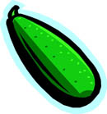
13. Gordon Greenthumbs likes to grow huge plants. He once grew a zucchini that started out at 6 inches, then grew 9 inches to be 15 inches on the second day. Each day the zucchini grew by the same amount as the day before plus another 3 inches. On which day would the zucchini be longer than 11 feet?

This will really challenge you...
Balancing Act
14. The sides of the following scale balance. Each shape is worth 1 to 10. Each shape has its own unique value that stays the same wherever the shape appears in the diagram. The total weight of the whole diagram is 32. What weight does each shape represent?
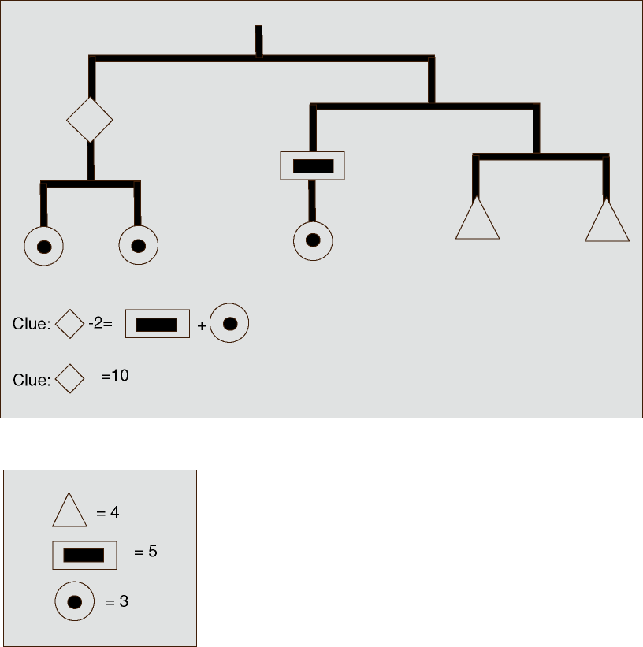

Data, Statistics, And Probability
Start out simple...
Cards
15. These questions are based on a standard deck of 52 playing cards.
- Give a set that would have a probability of 1/2.
- Give a set that would have a probability of 3/13. (12 cards)
- Give a set with a probability of 1/26. (2 cards)
- Give a set with a probability of 1/13. (4 cards)

Now try to work this out...
Popsicle Picking
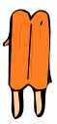
16. A box of 12 popsicles has equal numbers of cherry, orange, lime, and grape. Alex likes everything but lime. What is the probability that when Alex reaches into the box randomly, he will select a popsicle that he likes? Two days later, 2 cherry, 1 grape, and 1 lime have been eaten. Have Alex's chances of randomly choosing a lime popsicle gone up or down? Explain your answer.

This will really challenge you...
Friendly Firefighters - From BRAINTEASERS
17. Truck 57-1 pumps 750 gallons of water per minute
Truck 57-2 pumps 1000 gallons of water per minute
Truck 57-3 pumps 1250 gallons of water per minute
Truck 57-4 pumps 1500 gallons of water per minute
Truck 57-5 pumps 1750 gallons of water per minute
Chief Greg Henry and firefighters Chuck, Darren, Jim, and Vanessa drove the trucks from District 57 responding to a multiple alarm fire. The driver and crew of each truck worked to extinguish the fire.
- Vanessa and her crew pumped 45,000 gallons of water on the fire in half an hour.
- Chief Greg and his crew worked for 45 minutes pumping more water than Vanessa's crew, but less than Jim's crew did in an hour.
- Chuck and his team pumped the same amount of water as Vanessa's crew in the same amount of time as Jim's crew.
- Darren's crew worked for 45 minutes and pumped the most water on the flames.
Who drives each truck, and how much water did each crew use to douse the fire?

March Problems
Number Theory
Start out simple...
Tables And Stools
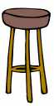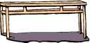
1. Vladmir builds 3 legged stools and 4 legged tables. Last month he used 72 legs to build 3 more stools than tables. How many stools and how many tables did he build?

Rainforests
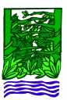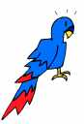
2. Rainforests cover only a small part of the Earth, but they are home to more than half the world's plants and animals. It is estimated that rainforests are cut down at the rate of 100 trees in a minute. At this rate, how many are cut down every 24 hours? Every week? Explain your answer.

Now try to work this out...
Who Are We?
3. There are 2 prime numbers between 100 and 199 such that the tens digit is a prime number, the ones digit is a prime number, and the tens and ones digits taken together are a 2 digit prime number. Find the sum of these 2 prime numbers.

Decisions, Decisions
4. Seymore has just gotten a new job. On his first day, the boss gave him 2 choices for his salary. First Choice: Start at $30,000 and get a 5% raise at the end of every year. Second Choice: Start at $23,000 and get a $5000 raise at the end of each year. Calculate how much Seymore would be making at the start of the 5th year. Which is the better choice? Explain how you got your answer.

This will really challenge you...
Car Shopping
5. Shawn bought a car for $5400. He sold it to Rachael for 5/6 the price he paid for it. Rachael sold it to Ray for 1/5 less than she paid for it. Ray sold it to Rick for 3/4 what he paid. What did Rick pay for the car?

Measurement
Start out simple...
Cubit
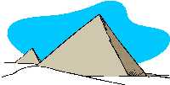
6. The ancient Egyptians used a measurement called a cubit to build the pyramids. A cubit was the distance from the bent elbow to the end of the middle finger. Using your own self as a measurement, find out how many inches in a cubit. If a pyramid is 100 cubits long, about how many inches is that?

Now try to work this out...
Mayan Pyramids
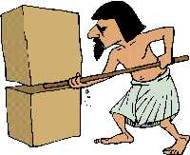
7. The Mayans of Mexico and Central America built huge pyramids of solid stone block.. The square base of one pyramid is 32 blocks on each side. Each block is 6' x 6' x 6'. What is the surface area of the base before the next layer is put on? Use only the sides you can see.

This will really challenge you...
Surface Area
8. Here is a sketch of a city park. It is 400 ' long and 300 ' wide. The sidewalks are 6 ' wide. What is the surface area of the sidewalk?

Geometry
Start out simple...
L
9. There are 9 cubes joined together in the shape of an L. If this is dipped in red paint and then taken apart, how many faces will be red?

Now try to work this out...
Hexagonal Tiles (from PROBLEM SOLVING CONNECTIONS)
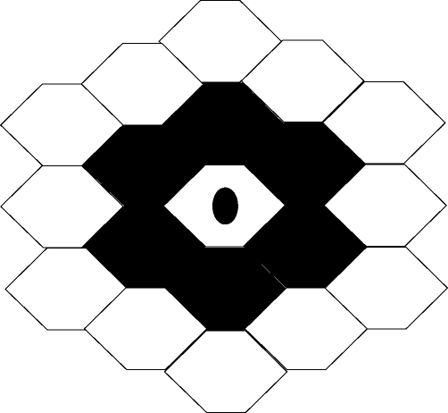
10. In the center of Memorial Park is a fountain in the shape of a hexagon. Workers are ringing the fountain in hexagonal tiles. The first ring of tiles is made of black tiles. The next ring is made of white tiles. The next black, and so on. How many hexagonal tiles will the workers use in the fourth ring?
In all, the workers completed 15 rings. What color were the tiles in the fifteenth ring? How many did they need for this ring?

This will really challenge you...
Triangular Tessellation
11. This is an equilateral triangle with sides 3 feet long. Gary plans on filling in the entire triangle with the smallest triangles. How many would he need? How many would he need to make a design that tessellates 12 ' long and 6 ' wide?
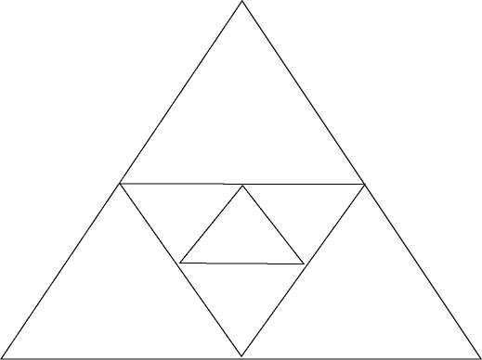

Patterns, Algebra, And Functions
Start out simple...
Mile Swim
12. Tiana and Shana are training for a mile swim. Each time they tried to get better times. The first week the best time for each of them was 70 minutes. Then Tiana had a best time of 66 minutes the second week, 67 the third week, 63 the fourth week and 64 the fifth week. Shana had a best time of 69 minutes the second week, 67 the third week, 66 the fourth week, and 64 the fifth week. If they continued at this rate, who would have the best time after 12 weeks of training? What would that time be?

Now try to work this out...
Legos
13. Jody, Amy, and Tim are building a model out of Legos. The top level is a 1 by 2 rectangle. The level directly underneath is a 2 by 3 rectangle. The level underneath is a 3 by 4 rectangle. How many Legos will they need if their building is to be 12 levels high? Make a chart to show your work.

This will really challenge you...
Coin Count (from MATH FORUM)
14. Everyday when Lisa returns from school she puts her change from buying lunch into a jar on her dresser. This weekend she decided to count her savings. She found that she had 72 coins—all nickels and dimes. The total amount was $4.95. How many coins of each kind did she have? See if you can find 2 different ways to solve this. Don't forget to explain your process.

Data, Statistics, And Probability
Start out simple...
Jellybean Jumble (from MATH FORUM)
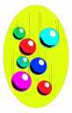
15. Mr. Cal Q. Later has a bag of jellybeans. As he walks around the room, he places a few jellybeans on everyone's desk—everyone's, that is, except Leo. On Leo's desk he places the bag with the remaining jellybeans. Here are the numbers:
17: Harumi
14: Melissa
13: Marcus, Evelyn
12: Kim, Toby, Lori
11: Jason
9: Efram, Inga
8: Hannah
6: Geoff
3: Luc
2: Muriel
Muriel and Luc are not worried because they know that Mr. Later is fair. Mr. Later tells the students that Leo's jellybeans are all that remain in the bag. If they figure out how many are in there, they will each get to eat the average number of jellybeans which is 10. How many jellybeans are in Leo's bag?

Now try to work this out...
The Prom
16. The Prom Committee is setting up card tables for the prom. One table seats 4, 2 tables together would seat 6, 3 tables 8. No table seats more than 12. Show 3 different ways that 16 couples could be seated for the Prom.

This will really challenge you...
Graph It!
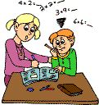
17. Make a double bar graph for the following information:
Mark's Math Test Scores
SEMESTER 1: 99, 87, 90, 76, 100
SEMESTER 2: 100, 85, 100, 95, 90
Now, find the range, median, mode, and mean for each semester.
April Problems
Number Theory | Measurement | Geometry |
Patterns, Algebra, and Functions | Data, Statistics, and Probability
Number Theory
Start out simple...
Mowing Lawns
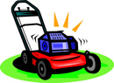
1. Ron and Darrell mow lawns to earn money in the summer. Ron has a riding mower. He charges $18 a yard and pays his little brother $7 to help. He is able to do 9 yards in a day.
Darrell has a walking mower. He charges $20 a yard and does 8 yards a day. Who do you think does better? Explain your answer.

Turkey Time
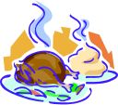
2. Julia Child was roasting a turkey. It has been out of the oven for 20 minutes. The turkey was roasting for 4 hours and 15 minutes. The oven was preheated for 10 minutes. If it is 5:00 now, then what time did Julia put the turkey in the oven?

Now try to work this out...
Jumping Frogs
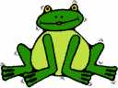
3. A frog jumped on several stones on his way to the pond. He did not land on the same stone twice. The product of all of the stones that he hopped on was 19,635. On which stones did he jump?
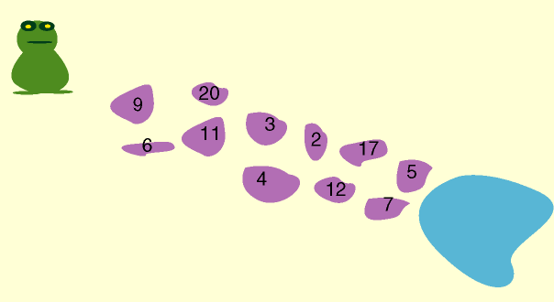

Multiplication Madness
4. Use multiplication to solve these arrays:
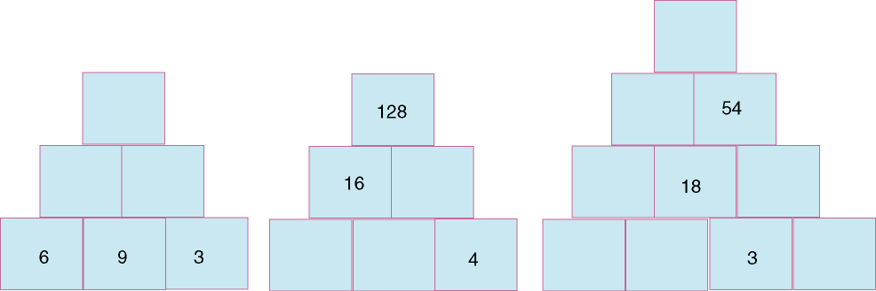

This will really challenge you...
Birthday Beach Bash (from Math Forum)
5. Twins Maggie and Dana and their friend Rebecca were celebrating their tenth birthdays with a party at the beach. The first fun activity was water games. As Chelsea arrived, she observed that 1/3 of the kids were playing with beach balls, 40% were exploring underwater with goggles, and .25 were floating on tubes.
The party continued with many games, presents, and the ever popular cake and ice cream. When the party was over, each kid received a party bag and a balloon to take home. There were even 3 left for Maggie, Dana, and Rebecca.
How many balloons were needed for the beach party?

Measurement
Start out simple...
Trees
6. The perimeter of a square lot is lined with trees. There are 3 yards between the centers of the trees. There are 8 trees on each side and a tree is at each corner. What is the number of yards in the perimeter of the lot? Explain how you got your answer.

Now try to work this out...
Baking Bonanza
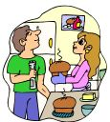
7. Jan is baking. She needs 4 cups of sugar. Her problem is that she only has a 1/2 cup measure and a 3/4 cup measure. What is the least number of scoops that she could make in order to get 4 cups? Explain your answer.

This will really challenge you...
Circles and Leaves
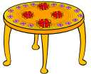
8. A circular table has an area of 1256 sq. in. The table opens in the middle to allow the addition of leaves. Each leaf is 12 " wide and is rectangular in shape. How many leaves must be added to change the area of the table to 2696 sq. in.? Work backwards and remember these formulas:
Area of rectangle = length x width
Area of a circle = pi x radius squared

Geometry
Start out simple...
Parallelogram Per Cents
9. What per cent of the quadrilaterals in this diagram are parallelograms?
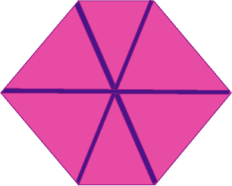

Now try to work this out...
Use Your Imagination
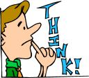
10. Create a symmetrical design with a perimeter of:
10cm
20cm
36cm
Do you think the perimeter is always even? Could there be a way for the perimeter to be odd?

This will really challenge you...
Inscribing Squares
11. Each of the squares shown is inscribed in a larger square so that the vertices of the inscribed square bisect the sides of the larger square. What fraction of the area of the largest square is shaded? Express your answer in simplest form.
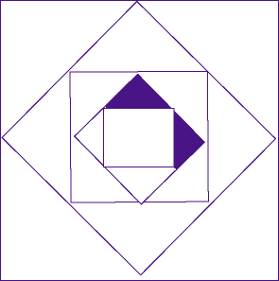

Patterns, Algebra, And Functions
Start out simple...
Slipping Snails
12. Upon your arrival on Monday morning, you observe a snail making its way up the wall of your cabin. Each day, it carefully works its way 30 inches up the wall. At night, though, it slips back down 12 inches. The cabin wall is 9 feet high. If the snail started on Monday, will it reach the top of the cabin wall before you leave on Friday afternoon?

Now try to work this out...
Pascal's Triangle
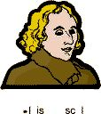
13. Fill in the blanks in this diagram. Tell the strategy you used to do this. Show 3 different patterns that you notice.
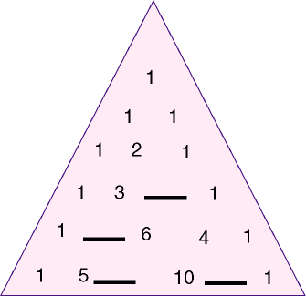

This will really challenge you...
Moving Cows
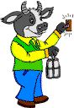
14. There are cows in each of these pastures. The pastures are connected by bridges. The number on each bridge tells the total number of cows in the 2 connecting pastures. Hint: no pasture has more than 20 or less than 10 cows.
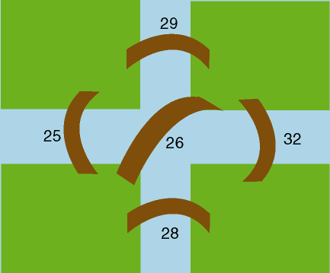

Data, Statistics, And Probability
Start out simple...
The Whole Thing
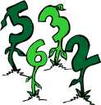
15. Two numbers are chosen at random with replacement from this set: (1, 2, 3, 4). The 2 chosen numbers are used as numerator and denominator of a fraction. What is the probability that the fraction represents a whole number? Express your answer as a fraction in simplest form.

Now try to work this out...
Building Bacteria
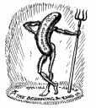
16. Consider 2 bacteria on a surface. The number of bacteria doubles every hour. Make a table and graph the results for n hours. Analyze the results.

This will really challenge you...
What's My Score?
17. Mrs. O. Angle has 12 students in her advanced algebra class. On a recent test, the average was 80. When Beth asked for her score, Mrs. Angle could not find it, but she did remember adding Beth's score in the average. She also remembered that Beth had passed. These are the scores of the other students:
65, 65, 70, 70, 80, 85, 85, 90, 90, 90, 100
Tell how Mrs. Angle can figure out the missing score. What is that score?

